Setting Up Your Story Map

1. Visit https://storymaps.arcgis.com/ and click Sign In:

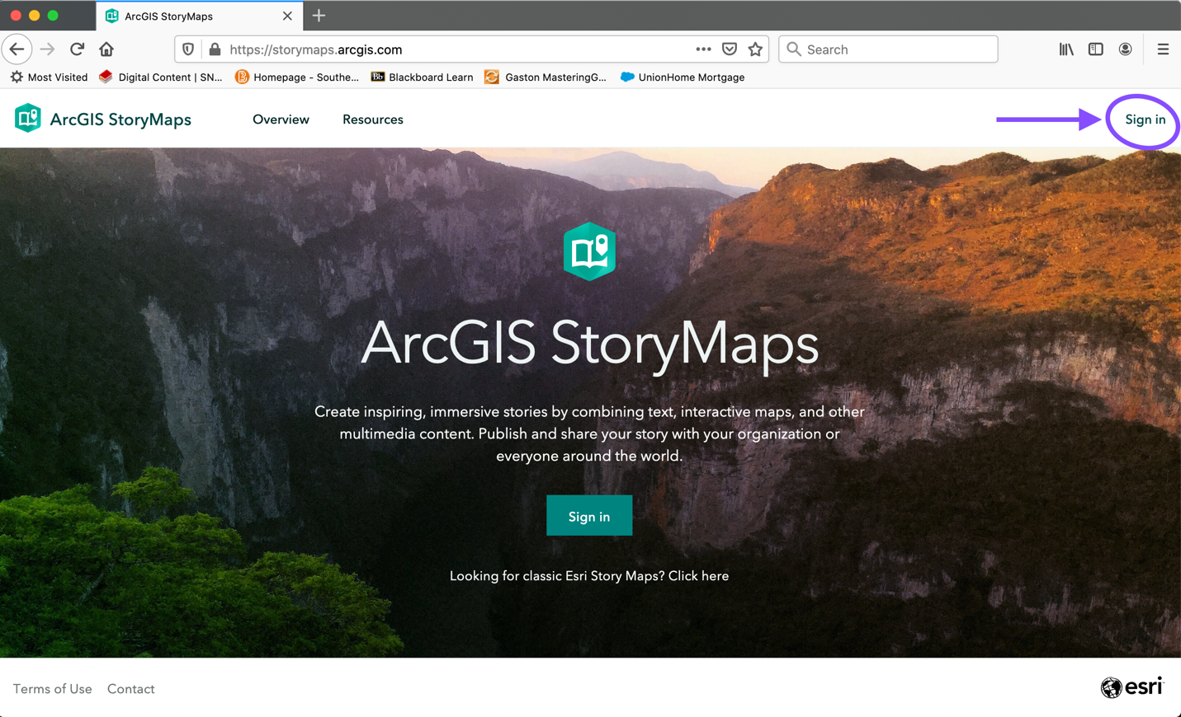

2. Create a Public Account:

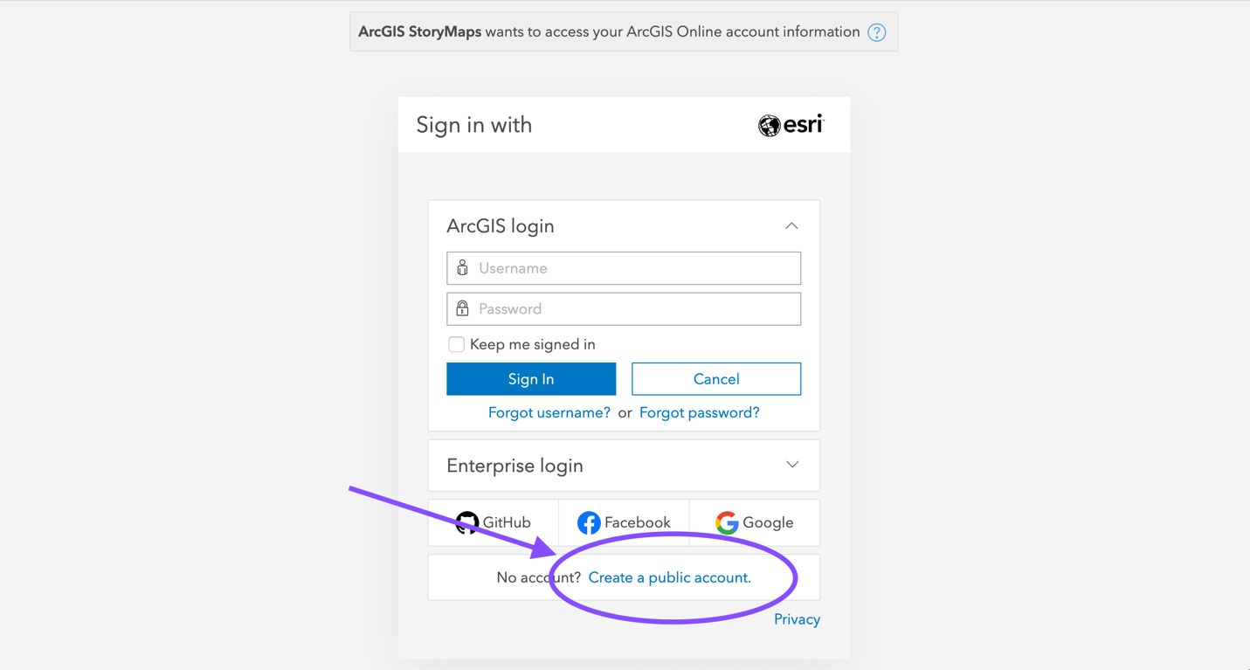

3. Enter your information. You will be sent an email confirmation to activate your account.

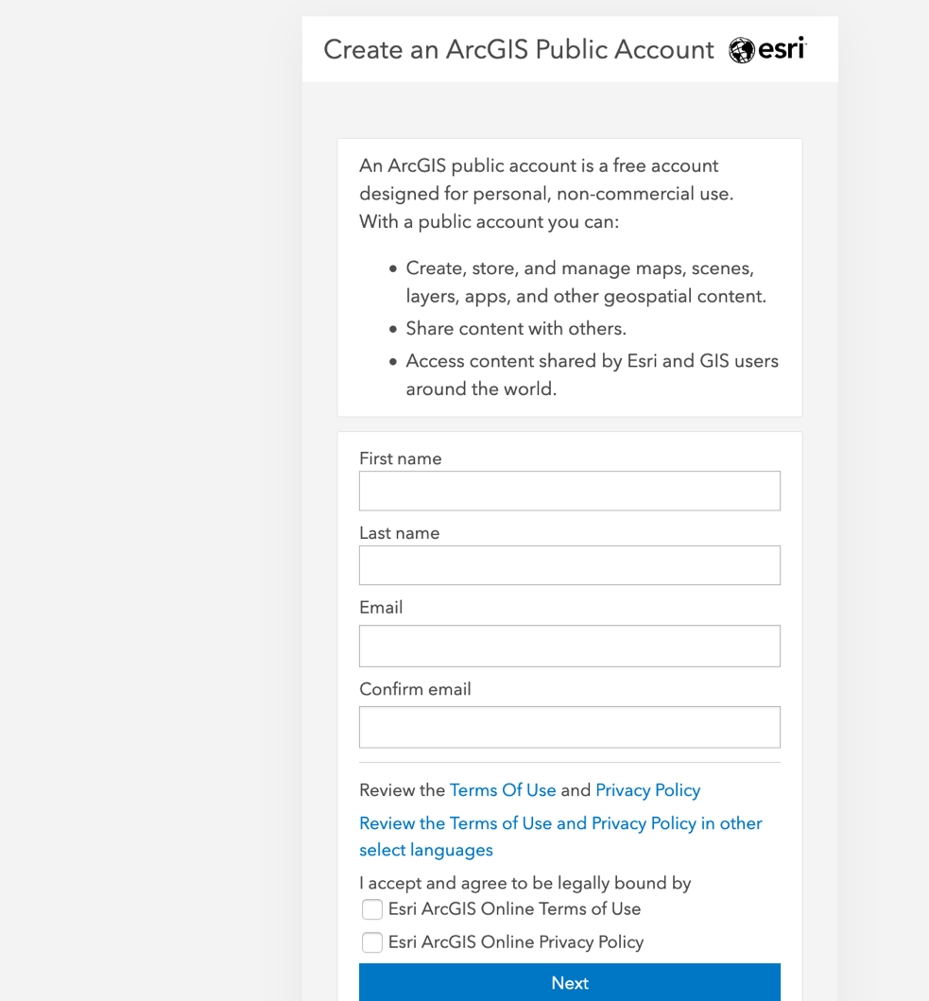

4. When you receive the activation email, click the link provided (expires within 24 hours). You will be redirected back to ArcGIS where you will need to come up with a username and password for your account:

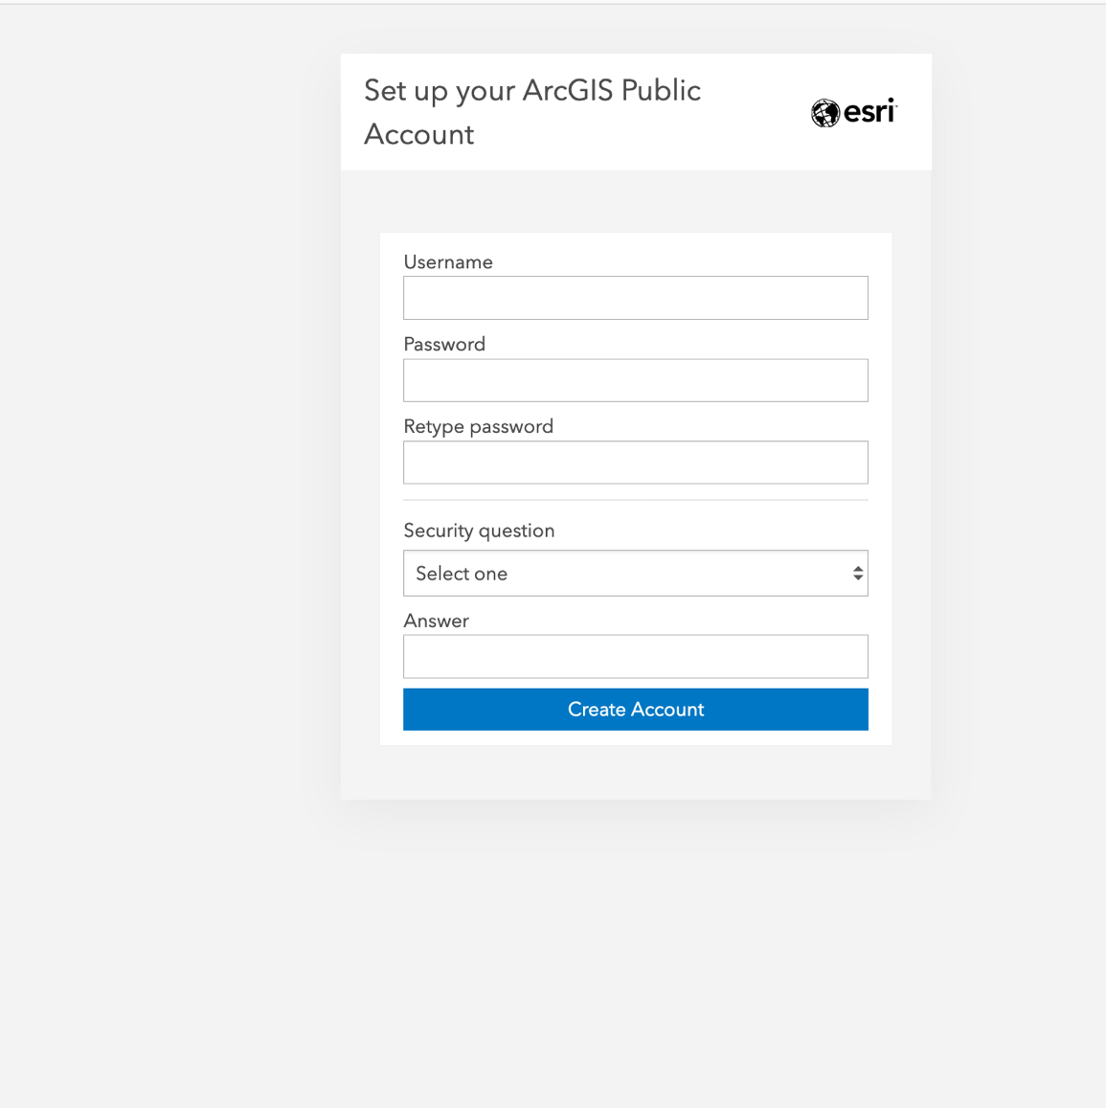

5. Your login will then open to this page. Click the icon to “Create your first story”:
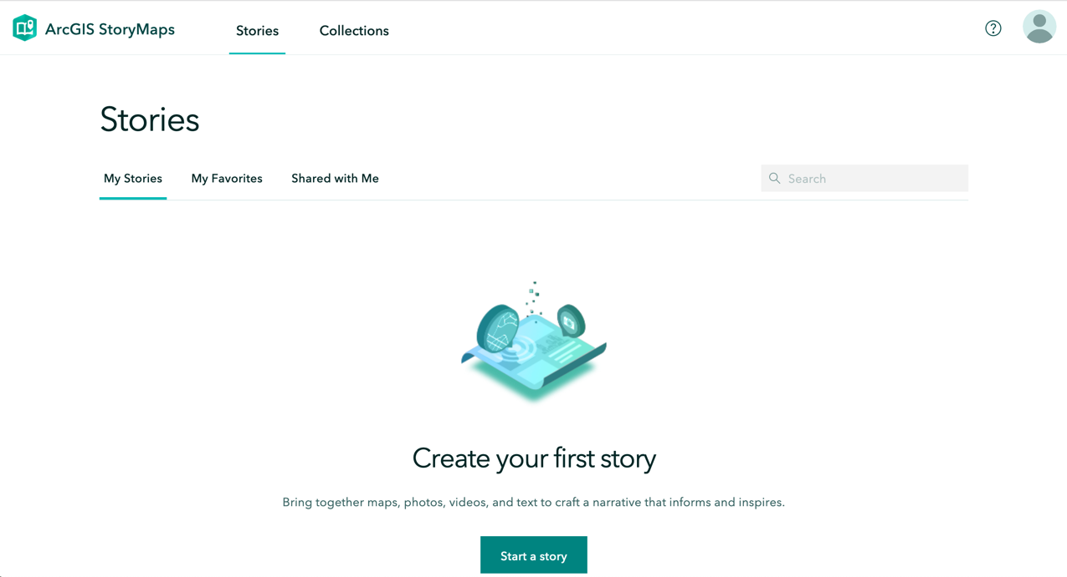

6. The new default presentation format will open. You have the option of either creating your Story Map using this design format, or you can create one using the Tour Map or Cascade designs (I personally like the Cascade design). To get to these other design templates, click the back arrow:
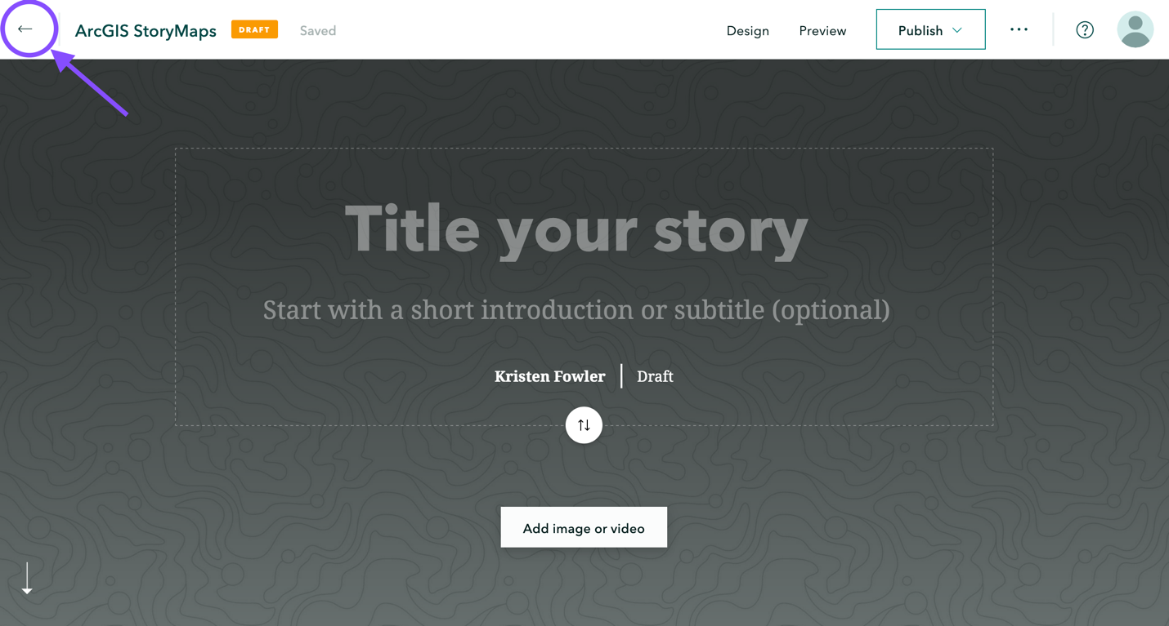

And find the information box on the main page telling you where to access the other story templates:
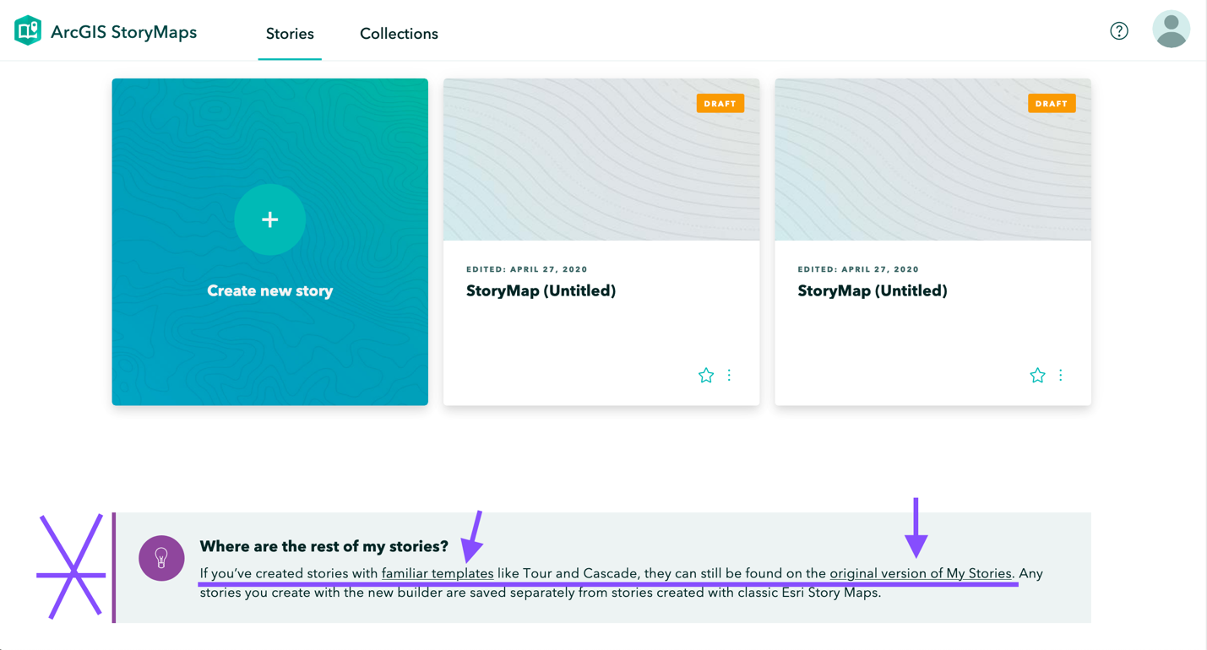

7. Once you’ve chosen your template, you can begin adding the text and pictures/embedded videos for your presentation.

8. Save your presentation often! When you “Share” your presentation (publish it and generate a link), you can still go back and edit your Story Map at your leisure – so don’t worry that you won’t be able to revise after you Publish! To make your presentation public, click the globe icon in the upper left:
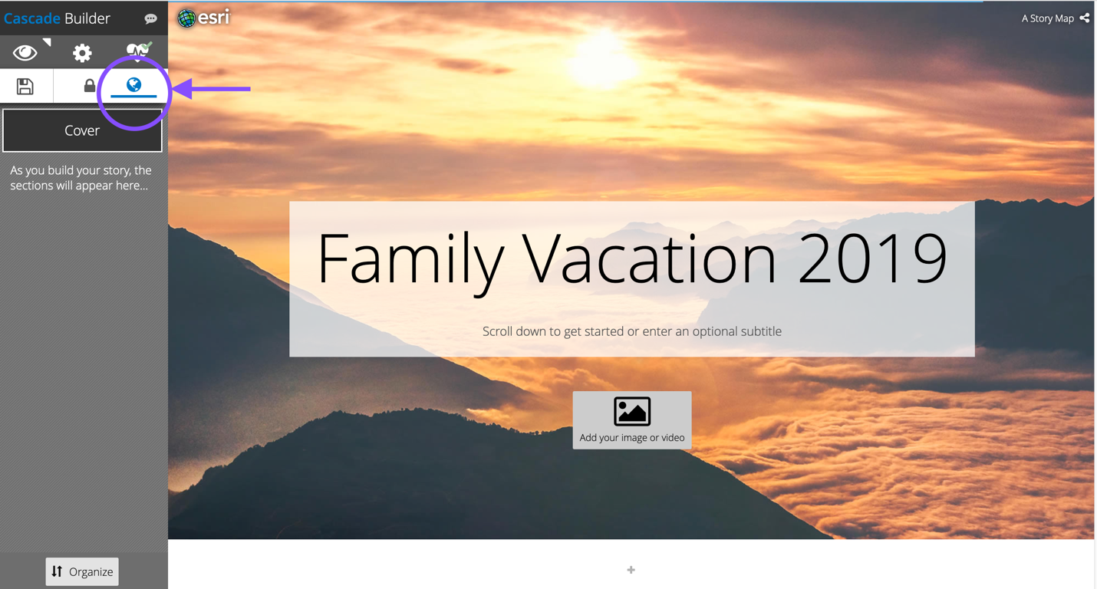

9. When you are ready to post the link to your Story Map in the discussion board, here is where you can find it:

